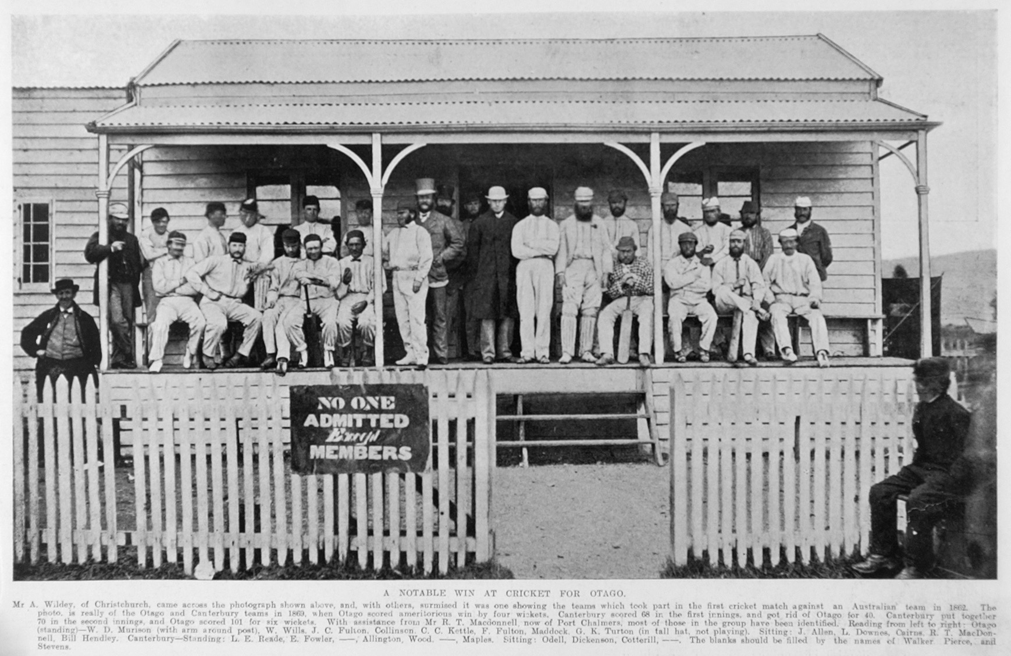

**Canterbury v Otago 3 December 1869** Mr A Wildey of Christchurch came across this photo and with others surmised it was one showing the teams which took part in the cricket match against an Australian team in 1862. The photo is really of the Otago and Canterbury teams in 1869 when Canterbury scored 68 and 70 while Otago scored 40 and 101 for six wickets, a victory to Otago by four wickets. With assistance from RT McDonell of Port Chalmers most of those in the group have been identified.

From left: Otago standing: WD Morison, JW Wills, JC Fulton, ET Collison, CC Kettle, F Fulton, HD Maddock, GK Turton (in tall hat not playing),

sitting: J Allen, WF Downes, HW Cairns, RT McDonell, W Hendley.

Canterbury standing: LE Reade (not playing), E Fowler, ---- WH Allington, J Wood, --- E Maples,

sitting: CS Odell, G Dickenson, AJ Cotterill,